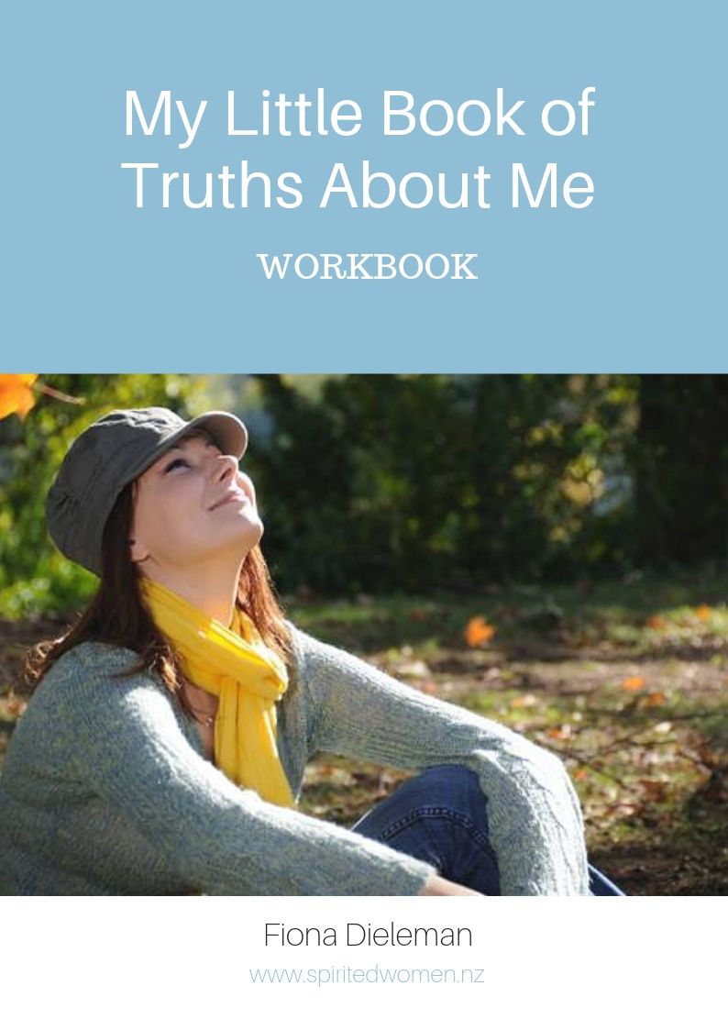

My Little Book of Truths
About Me
This little work book is a place for you to value and affirm the goodness of who you are and what you carry in you. Take your time completing it. Be honest but kind to yourself. Let it be a time of discovery about the truth of who you are, not who others say you are, or who others expect you to be, but who you want to be. Make it a dream place for the life you want to live.

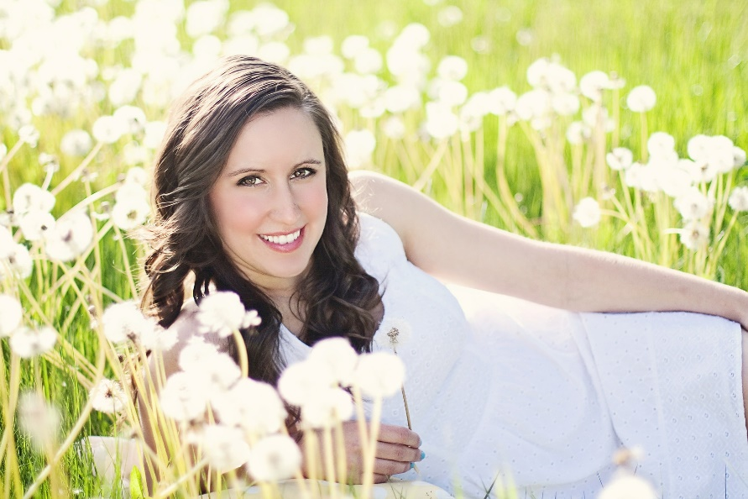

These words describe my best self and the things I like about ME!

These words describe who I would like to be.

These are the things that make me happy.

These are my dreams for my future.

These are the things I am going to tell myself every day.

These are the things I am grateful for.

These things are important in my life. They are the principles I want to live by.

I want the people in my life to have these wonderful traits.

I want to make a difference in the world by....

These are some other thoughts and ideas I’ve had about me and my life.

A note from Fiona:

This little book is special to me. I created it to help you to discover the goodness inside of you. It’s not an expensive book. Your purchase enables me to create others. Please respect my copyright and do not share it. Thank you.
Fiona Dieleman, www.spiritedwomen.com, 2016

